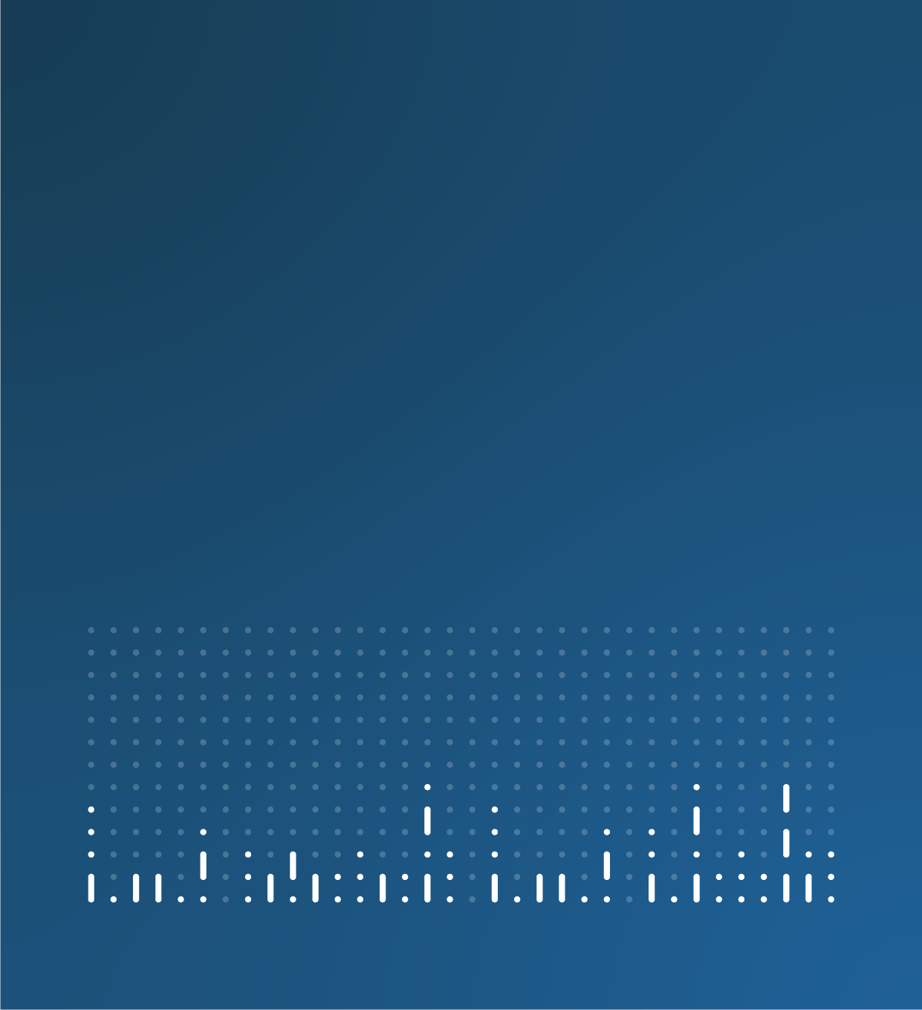

Statistical Bulletin

[Insert title - topic, geography: data period]

Official statistics – please treat as restricted, for named individuals or identified postholders only. Not for sharing with anyone else or to be used in other documents before publication.

[Insert title - topic, geography: data period]
[Insert Summary]

1. Main points
- X example
- X example
- X example

2. [Topic] (single or multiple analysis sections)

Subheading
Content
[Copy and paste this section for each analysis section]

3. [Topic] data
Dataset title with link embedded
Dataset | Released XX Month 20XX
Summary of dataset

4. Glossary

Term
Definition

5. Measuring the data

Subheading
Content

Quality
More quality and methodology information on strengths, limitations, appropriate uses, and how the data were created is available in the [name of release] QMI.

6. Strengths and limitations

Subheading
Content

7. Related links
Title with link embedded
Content type | Released XX Month 20XX
Summary of page or publication

8. Cite this statistical bulletin
Office for National Statistics (ONS), released XX Month 20XX, ONS website, statistical bulletin, Title: edition with link embedded

Other pages in this release (optional section 1.)
Introductory sentence to bullet list of links to other bulletins (or pages) in this release:
- Title with link embedded
- Title with link embedded
- Title with link embedded

Bullet list example:
- X example
- X example
- X example

This is a hyperlink

Figure X: Descriptive title
Statistical subtitle, geography and data period

Table X: Statistical title, geography and data period

Warning: This is the warning text

