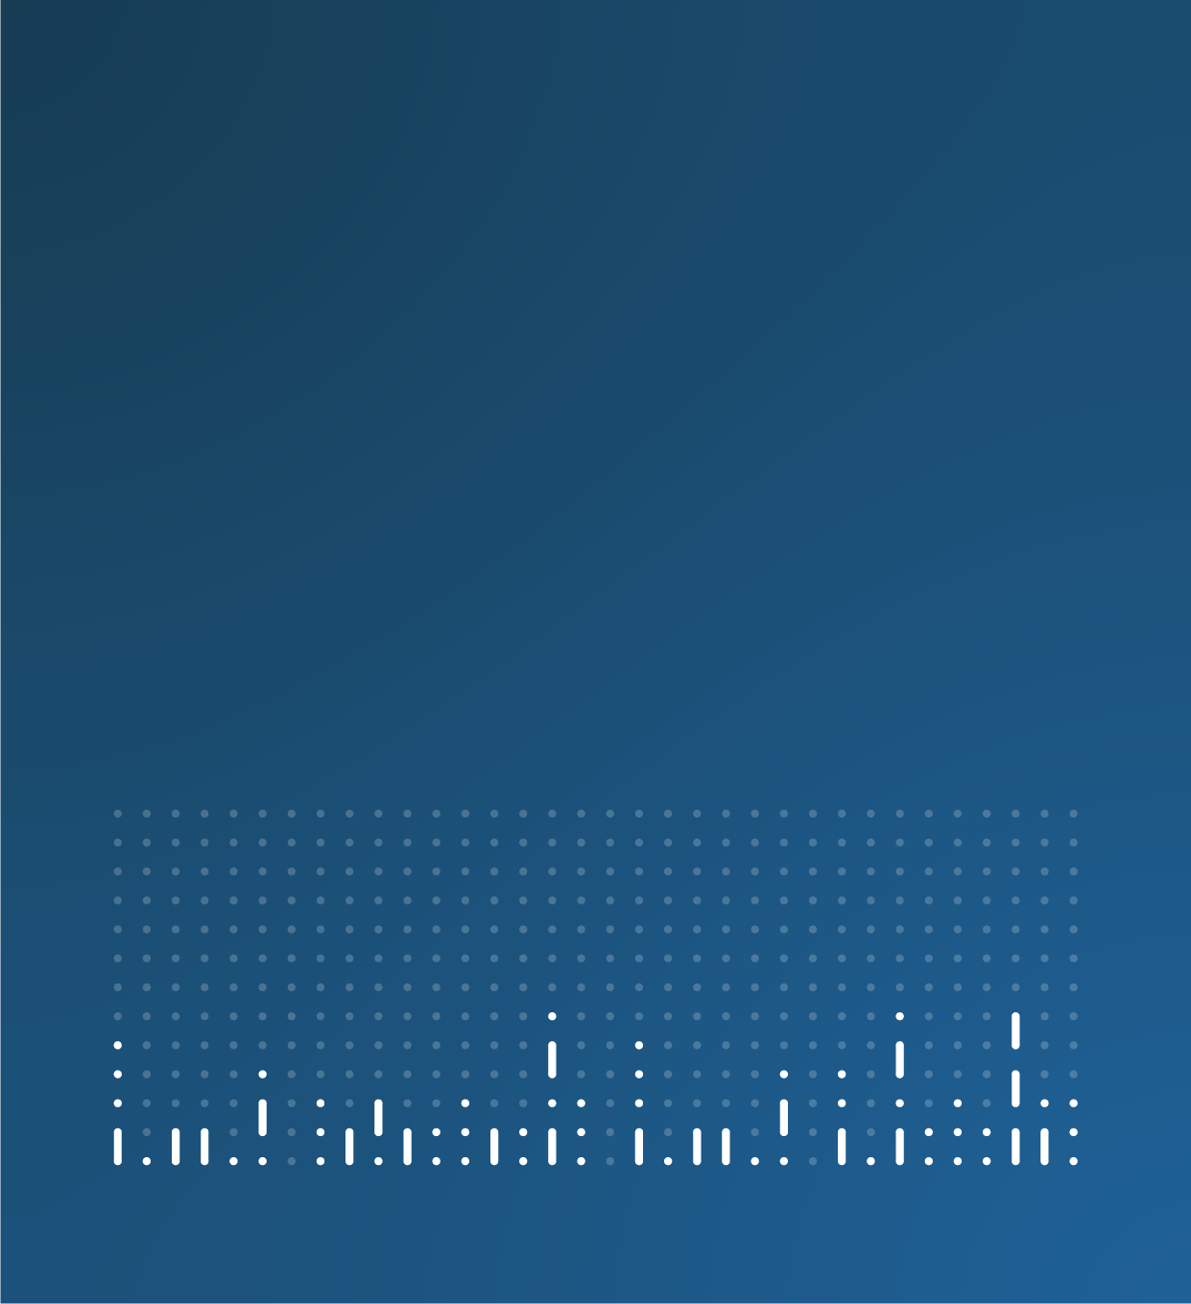

Research outputs article template

[Insert title - topic, geography: data period]

[Insert title - topic, geography: data period]
[Insert summary – mention that these are official statistics in development]

1. Main points
- X example.
- X example.
- X example.

Warning
[Standard warning text: These are official statistics in development and we advise caution when using the data. The [method/data source] is currently under [review/development], which means [short description about how this affects the quality]. Read more in the Data sources and quality section.]

[View our warning guidance for official statistics in development.]

2. [Labelled analysis section(s)]

Subheading
Content
[Copy and paste this section for each analysis section – you can use a single section if your article is short or use multiple sections if your content contains several topics or detailed analysis.
It is recommended you frontload your analysis section with the development of your research outputs and how they are intended to be put into practice. A separate analysis section should be used for outcomes or comparisons of these research outputs.
Use clear label headings for each section, for example, Knife crime.]

3. [Topic] data (optional)
[If your research outputs include the publication of datasets alongside the article, including dummy data, include a data section with up to six links.]

Title with link embedded
Content type | Released XX Month 20XX
Summary of page or publication

4. Glossary

Term
Definition

5. Data sources and quality

Subheading
Content

6. Future developments

Subheading
Content

7. Related links
Title with link embedded
Content type | Released XX Month 20XX
Summary of page or publication

8. Cite this article
Office for National Statistics (ONS), released [XX Month 20XX], ONS website, [content type], [Title: edition with link embedded]

Formatting

Bullet list example:
- X example
- X example
- X example

This is a hyperlink

Figure X: Descriptive title
Statistical subtitle, geography and data period

Table X: Statistical title, geography and data period

