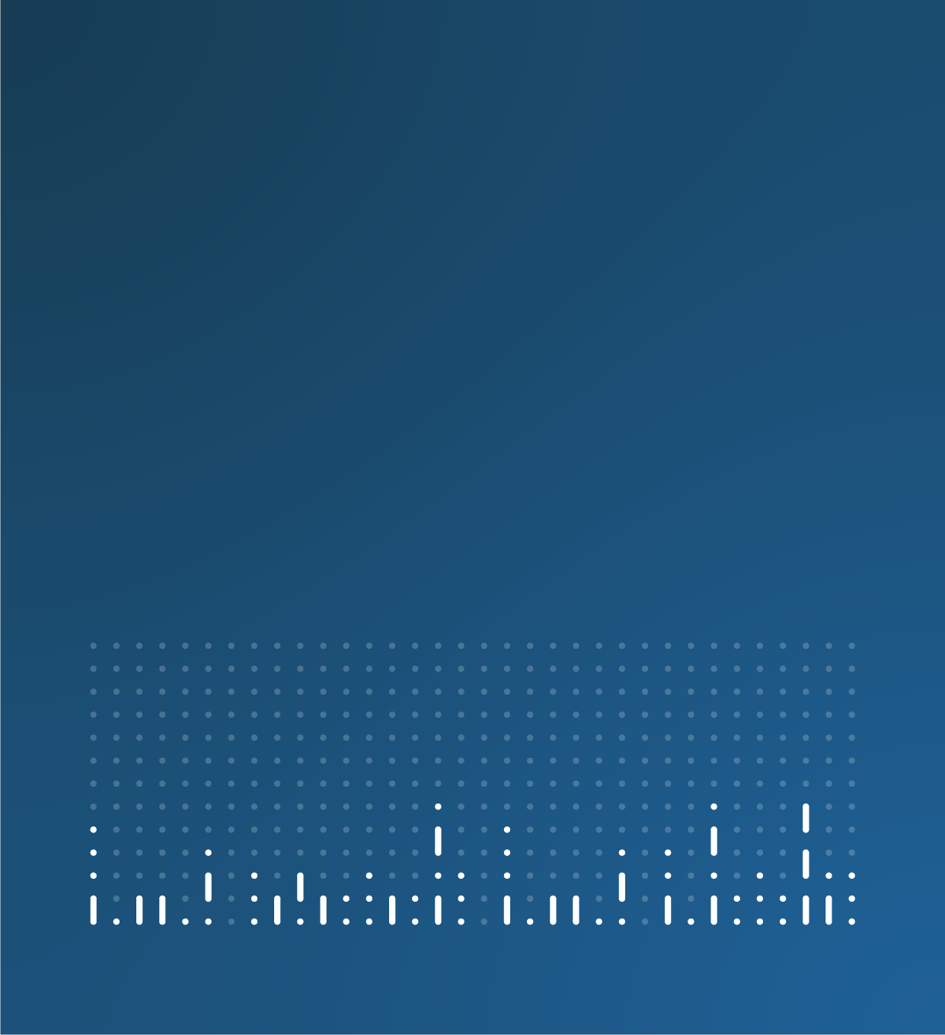

Current and upcoming work article template

[Insert title]

[Title: Theme, topic or emerging trend], current and upcoming work: [month and year of publication]
[Insert summary]

1. Overview of [theme, topic or emerging trend]
This section should have a few short, succinct paragraphs detailing what the intent of the article is and how your team arrived at this point. This can be just one paragraph if necessary but should be no more than five.

This should cover:
- the topic or theme
- why the current and upcoming work article is required
- what you broadly want to tell users about your past, current and future work
If you need to provide more detail on the background of the topic, you can include an additional section after the overview. This should be kept as brief and clear as possible, with links provided to any further information. Use a clear and descriptive section heading that tells the user what it is about. For example, use “Measures of price change” rather than “Background”.

2. Our current position
This section should focus on what work has been done up to this point and what work is being produced by your team now.
You should focus on important projects and aims throughout this section. This section can also cover work that will continue to be produced that is not going to change significantly over time.
This section should be broken down by theme or sub-theme by using clear sub-headings.

Description of sub-theme
We have published:
- Output X
- Output X
We are working on/We are continuing to work on:
- Output X
- Output X

3. Upcoming work
In this section, you should focus on important publications, milestones, projects and aims while describing your future work. This should cover what you will start working on before the next edition of the article.
This section should be broken down by theme or sub-theme by using clear sub-headings. It must also be broken down into definite deliverables.

Description of sub-theme
We will publish:
- Output X
- Output X

4. Future developments (optional)
In this section, you can provide a paragraph summarising any more tentative future research and development plans. It should be kept brief and ideally no more than 150 words.

You should include any requests for support you might want to declare as well as list any opportunities you are seeking to explore based on securing funding, resource, support from academia or any other interdependencies.

5. Provide feedback
This section should use the standard wording and always be included in the article. The standard wording is as follows:

This content will be reviewed [on XX Month Year/quarterly/biannually/annually].
If you have any feedback or suggestions on the work we are doing around [topic/theme], please contact us at XXXXX@ons.gov.uk.

6. Publication schedule (optional)
In this section, you can list any relevant upcoming publications that are related to the theme covered in the article. These will be divided between regular releases and one-off publications.
Always link to the /latest version of regular releases, or one-off releases that have already been published, rather than a specific edition. This is to ensure users are always directed to the latest release when new editions are published and avoids the links becoming quickly outdated. Only link to a specific edition if there is a clear user need to do so.
For one-off releases that have not yet been published, link to the upcoming release calendar entry. When the release is published the user will be able to access the publication through the calendar entry link.
Do not include a release date for regular releases as these will quickly become outdated. Also do not include a release date if linking to the release calendar entry, as the date on the release calendar will update if the publication date changes.

We publish regular releases related to [the theme/topic]:
- Hyperlinked release title (publication frequency, such as weekly, monthly, quarterly, annual)
- Hyperlinked release title (publication frequency)
We also publish ad-hoc releases related to [the theme/topic]:
- Hyperlinked release title
- Release title (no link available): Release date

7. Related links (optional)
In this section, you can include relevant and useful links. You can use this section to highlight a link to users instead of repeating it multiple times in the main content.

Content Design might ask you to add some related links if they feel that the links are important or related to the topic. This section should usually have a maximum of six links.

Title with link embedded
Content type | Released XX Month 20XX
Summary of page or publication

8. Cite this article
Office for National Statistics (ONS), released XX Month 20XX, ONS website, article, Title: edition with link embedded

Formatting

Bullet list example:
- X example
- X example
- X example

This is a hyperlink

